**IMPLEMENTATION:**

**LANDER PAGE**

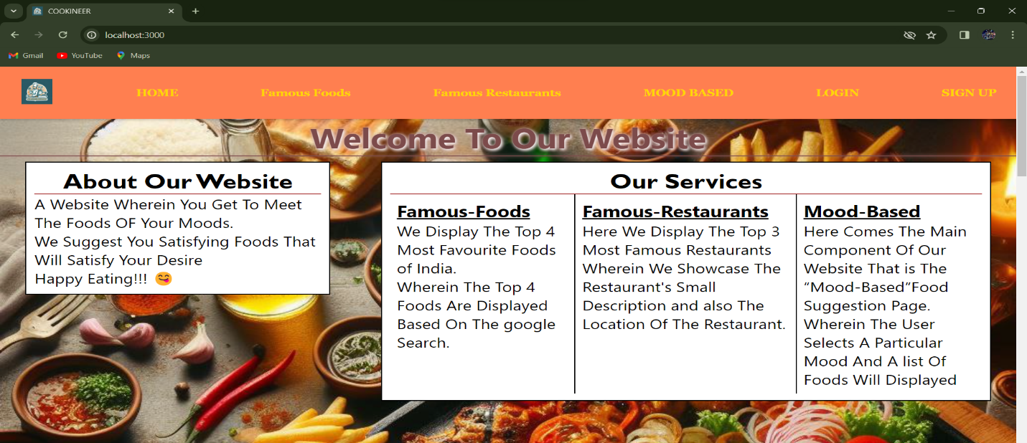

**-------------------------------------------------------------------------------------------------------------------------------------------------------------------------------------------**

**FAMOUS RESTAURANTS WITH THEIR LOCATION**

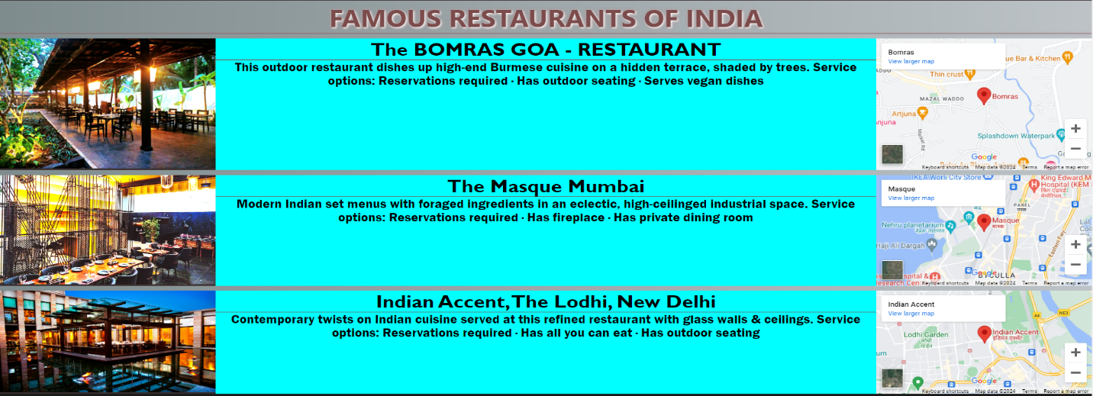

**-------------------------------------------------------------------------------------------------------------------------------------------------------------------------------------------**

**LOGIN PAGE**

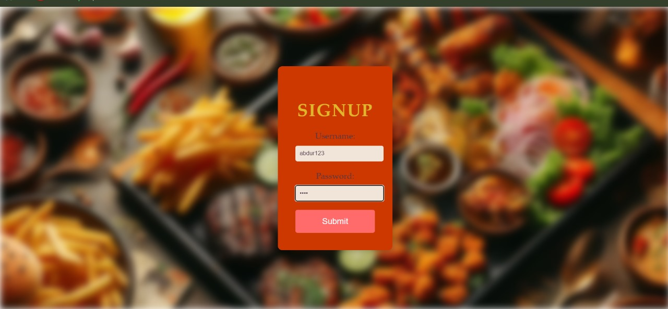

**-------------------------------------------------------------------------------------------------------------------------------------------------------------------------------------------**

**MOOD CHOOSER**

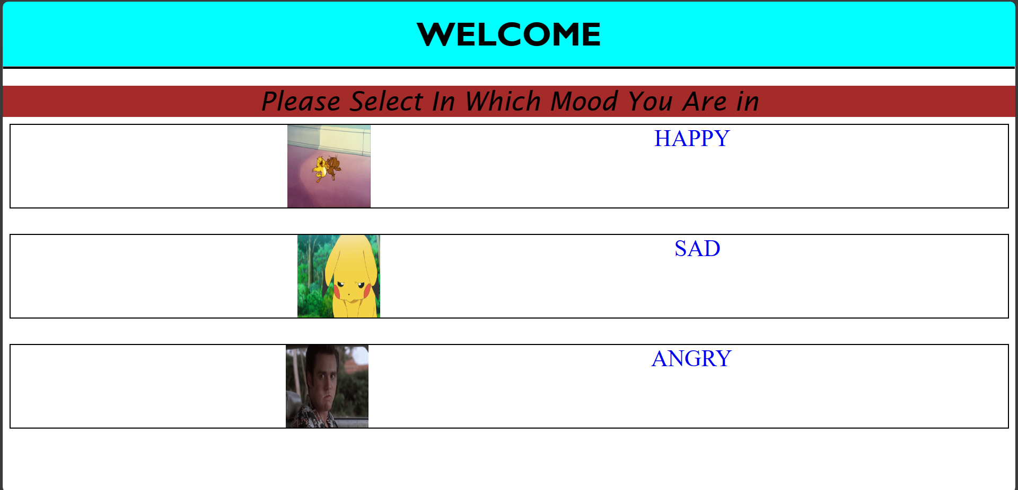

**-------------------------------------------------------------------------------------------------------------------------------------------------------------------------------------------**

**MOOD BASED FOOD RECOMMENDATION**

**FOR EXAMPLE ANGRY MOOD**

